

A PROJECT REPORT

ON

FRAUD DETECTION USING E-RATION

DONE BY

Achal A. Sakure

(EBEON0920321591)

Under the Guidance of,

**Mr. V JAYANTH**

**Technical Trainer**

**NASSCOM PROJECT**

**­**

**ARISE**

**ONCAMPUS**

**SOFTWARE DEVELOPER TRAINEE**

Tambaram, Chennai-600045 (Tamil Nadu)­­

2020

**ABSTRACT**

Public distribution system i.e. rationing distribution is one of the widely controversial issues that involves corruption and illegal smuggling of goods. All these happen because every job in the ration shop involves manual work and there are no specific high-tech technologies to automate the job. Because of intervention of manual work there are lots of illegal activity occurs like wrong entry in register of shop about the amount of products that given to the people, sometimes there is chance of distribution of low quality products than actual product provided by government for poor people, people do not have idea about how much quantity of good provided by government to them etc. In this paper we propose the concept about to replace manual work in public distribution system (rationing distribution system) as E-government is increasingly used to improve transparency in the government sector and to combat against corruption. E-government is being implemented in more areas of government administration for both the local and national levels worldwide. E- Rationing system will reduce corruption in ration shops. In this paper, online registration will done by user and user will fill his personal information and family information in system. Every time before ration collection, the authorized person needs to go through the verification phase. Once verification is done, quantity that he will collect also logged into the system. Therefore not only false and dummy card ration collection is avoided but at the same time a proper log of quantity but product acquired by the card holder will also tracked.

**TABLE OF CONTENT**

**S. TITLE PAGE**

**NO**

ABSTRACT

**1. INTRODUCTION TO THE STUDY 5**

1.1 Introduction 5

1.2 Definition of the Problem 5

1.3 System Requirement 6

* Hardware Requirement
* Software Requirement

**2. AIMS & OBJECTIVES OF THE STUDY 7**

2.1 Objective

2.2 Goals

**3. LITRATURE REVIEW 8**

**4. RESEARCH METHODOLOGY 11**

4.1 Planning 11

4.2 System Architecture 12

* Activity Diagram
* Data Flow Diagram

**5. SYSTEM DESIGN 14**

5.1 System Study 14

· Feasibility Study

5.2 Input Design 15

5.3 Output Design 15

**6. SYSTEM ANALYSIS 16**

6.1 Advantages

6.2 Outcome

6.3 Application

**7. CONCLUSION 17**

**8. REFERENCE 17**

**APPENDIX-I**

* **SNAPSHOTS 18**

**CHAPTER – 1**

1. **INTRODUCTION TO THE STUDY**

**1.1 INTRODUCTION:**

Ration card is a very necessary document for every citizen in India. Ration card is used to purchase various necessary items like sugar, oil etc. from the ration shops at a cheaper rate, issued by the government. This ration card also acts as address as well as identity proof. Ration card is needed when you apply for passport, PAN number, driving license etc. Hence, ration card is a very important document. But, the current ration card system has a drawback, that if the items are not sold up to the last of the month, then the shopkeeper will sell it to someone else and take the profit into his pocket and put some false reading in the government record diary. Public Distribution System (PDS) is an Indian food security system. It is established by the Government of India under Ministry of Consumer Affairs, Food, and Public Distribution and managed jointly with state governments in India. The traditional PDS is used to distribute grocery items to India's poor who are valid ration card holders. The validity and the allocation of the ration cards is monitored by the state governments. A ration card holder should be given 35 kg of food grain as per the norms of PDS. However, there are concerns about the efficiency of the distribution process. In order to make it efficient and improve the current system. Using this System, the card holder can get his/her grocery items from the Fair Price Shop's. The main reason for using this System is, to avoid the problems like duplication of cards, Forgery in Supplying food materials. Issuing products based on ration card.

**1.2 DEFINITION OF PROBLEM:**

Now a days ration card is very important for every home and it is used in various ﬁelds such as family members details. It acts as an address proof for various purposes etc. All the people having a ration card can buy the various materials (sugar, rice, oil, kerosene, etc) from the ration shops. there is a chance for the illegal usage of our products in the regular system, i.e. the materials are robbed by making wrong entries in the register without the insight of the ration card holder. Due to that large amount of money given by government gets wasted.

**1.3 SYSTEM REQUIREMENT:**

* **Hardware Requirements:**
* System : Pentium IV 2.4 GHz.
* Hard Disk : 40 GB.
* Floppy Drive : 1.44 Mb.
* Monitor : 15 VGA Colour.
* Mouse : Logitech.
* Ram : 512 Mb.
* **Software Requirements:**
* Operating system : Windows XP/10.
* Coding Language : JAVA.
* IDE : eclipse.
* Database : MYSQL.

**CHAPTER – 2**

1. **OBJECTIVES & GOALS OF THE STUDY**

**2.1 OBJECTIVE:**

* Increased corruption in the Government as well as market sector can be prevented
* Individual Ration Card search is based on family members Aadhaar number/mobile number.

**2.2 GOALS:**

* False and dummy card ration collection is avoided
* To reduce corruption in ration shops.
* To improve transparency in the government sector.

**CHAPTER – 3**

1. **LITERATURE REVIEW**
2. **Smart ration card.**

Author: Mrs. B. Buvaneswari

The Ration Shop cannot able to meet the requirement of the user due to over population of our country, so the processing speed is low. As a result, there is always crowd of people in the ration shop. Also there is a chance for the illegal usage of our products in the regular system, i.e. the materials are robbed by making wrong entries in the register without the insight of the ration card holder. Due to that large amount of money given by government gets wasted. Hijacking is the main problem in the user ration card. Hence, we have developed a smart ration card application for all android mobile users.

1. **Web Enabled Ration Distribution and Corruption Controlling System.**

Author : Dhanashri Pingale, Sonali Patil, Nishigandha Gadakh, Reena Avhad, Gundal

S.S

Corruption has been around for a very long time and will remain in the future unless governments can figure out effective ways to combat it (Mauro 1997). E-government is increasingly used to improve transparency in the government sector and to combat against corruption. E-government is being implemented in more areas of government administration for both the local and national levels worldwide. E-government system developed to reduce corruption. The aim of this paper is to organize and summarize existing theoretical and empirical work on corruption with a view identifying opportunities for further research. Computerization can help in modernizing the PDS. The southern states as usual have led the way on many reforms intended to address the issues above, and increasingly even poorer states have introduced changes in policies and implementation mechanisms to address the problems of PDS. This paper discusses strategy adapted in using ICT to control diversion and leakage in the delivery mechanism and its successful application in computerization of food grain supply chain. As an outcome of the project, 0.78 Million farmers have received computer generated cheques without any delay. Citizen involvement in the system has been increased in monitoring PDS.

1. **Ministry of Consumer Affairs, Food and Public Distribution Department of Food and Public Distribution, Annual Plan 2011-12.**

Department of Food & Public Distribution is one of the two Departments under the Ministry of Consumer Affairs, Food and Public Distribution. The Ministry was under the charge of Prof. K. V. Thomas, Minister of State (Independent Charge) for consumer Affairs, Food & Public Distribution with effect from 19th January, 2011. Shri Ram Vilas Paswan has taken over charge as Minister for Consumer Affairs, Food & Public Distribution and Shri Raosaheb Dadarao Danve as Minister of State for Consumer Affairs, Food & Public Distribution with effect from 27th May, 2014.

1. **Web-Enabled Ration Distribution and Controlling.**

Author : Neha Pardeshi , Trupti Desale, Prajakta Bhagwat, Ruchali Ahire

E-government is increasingly being used to improve transparency in the government sector and to combat corruption. A well-planned e-government strategy can build a more efficient, accountable and transparent government. We first analyze the theoretical background of anti-corruption strategy which illustrates the advantages of e-government services. Second, discusses two examples of e-government where corruption was significantly reduced and draws lessons on leadership and managerial issues in deploying information and communication technology (ICT) to combat corruption. In addition, let us discuss the e-government as an anti-corruption strategy in India and point out the urgent tasks for good egovernment in India. Finally, let us analyze some challenges to the development of the e-government system and its existing problems. Here efforts from our side are done to overcome one of the corruption problem involve in ration distribution system through a kind of electrodynamics web template where distribution of kerosene, rice, wheat etc. at rural and urban areas, will be checked, monitored and controlled with filtering the problem of corruption and adulteration.

1. **Automatic Rationing for Public Distribution System (PDS) using RFID and GSM Module to Prevent Irregularities**.

Author : Rajesh C. Pingle∗and P. B. Borole

Public distribution system i.e rationing distribution is one of the widely controversial issue that involves corruption and illegal smuggling of goods. One reason of this to happen is because every job in the ration shop involves manual work and there is no specific technology involved in automating the job. Involvement of manual work calls a lots of irregularities. These irregularities or illegal activities are for example - wrong entries in stock register of shop containing wrong stock information of the products that is ∗Department of Electrical Engineering, Veermata Jijabai Technological Institute, Mumbai, Maharashtra, India †Department of Electrical Engineering, Veermata Jijabai Technological Institute, Mumbai, Maharashtra, India Rajesh C. Pingle and P. B. Borole Automatic Rationing for Public Distribution System (PDS) using RFID and GSM Module to Prevent Irregularities. Page 102 HCTL Open Int. J. of Technology Innovations and Research HCTL Open IJTIR, Volume 2, March 2013 e-ISSN: 2321-1814 ISBN (Print): 978-1-62776-111-6 supplied to the public, sometimes there are chance of distribution of low quality/graded products than the actual products provided by the Government for supplying to the public, also the information regarding the actual available stock quantity in a ration shop that is provided by the Government to the public. In this paper we propose the concept of replacing manual work/job in public distribution system (rationing distribution system in India) by automated system which can be installed at the ration shop with ease. In this automated system we replace the conventional ration card by smart card in which all the details about users are provided including their AADHAR (social security) number which is used for user authentication. This prompted us to interface smart card reader (RFID Based)to the microcontroller (AT89C51) and PC via RS232 to develop such a system. Using such a sytem, Government would have all required control/monitoring over the transactions at ration shop. To involve Government in the process we proposed connecting the system at ration shop to a central database (provided by Govt.) via GSM module (SIM900D) and RS232. Hence it is possible to prevent the corruption and irregularities at ration shop. This would bring the transparency in public distribution system as there will be a direct communication between people and Government through this.

**CHAPTER – 4**

1. **RESEARCH METHODOLOGY**

**4.1 PLANNING:**

Plan on starting or continuing with an activity and define the activities.



Figure 4.1.1 : Activity Diagram

Activity diagrams are graphical representations of workﬂows of stepwise activities and actions with support for choice, iteration and concurrency. In the Uniﬁed Modeling Language, activity diagrams can be used to describe the business and operational step-by-step workﬂows of components in a system. An activity diagram shows the overall ﬂow of control. A use case diagram in the Uniﬁed Modeling Language (UML) is a type of behavioral diagram deﬁned by and created from a Use-case analysis. Its purpose is to present a graphical overview of the functionality provided by a system in terms of factors, their goals (represented as use cases), and any dependencies between those use cases. The main purpose of a use case diagram is to show what system functions are performed for which actor. Roles of the actors in the system can be depicted.

Use Case View Use Case Diagram. Example is given below

* Captures system functionality as seen by users
* Built in early stages of development
* Developed by analysts and domain experts
* System behavior, that is what functionality it must provide, is documented in a use case model.



Figure 4.1.2: Use case Diagram

* 1. **SYSTEM ARCHITECTURE:**
* **Data Flow Diagram:**

1. The DFD is also called as bubble chart. It is a simple graphical formalism that can be used to represent a system in terms of input data to the system, various processing carried out on this data, and the output data is generated by this system.

2. The data ﬂow diagram (DFD) is one of the most important modeling tools. It is used to model the system components. These components are the system process, the data used by the process, an external entity that interacts with the system and the information ﬂows in the system.

3. DFDs how show the information moves through the system and how it is modiﬁed by a series of transformations. It is a graphical technique that depicts information ﬂow and the transformations that are applied as data moves from input to output. 4. DFD is also known as bubble chart. A DFD may be used to represent a system at any level of abstraction. DFD may be partitioned into levels that represent increasing information ﬂow and functional detail.



Figure 4.2.1 : Level 0 Data Flow Diagram



Figure 4.2.2 : Level 1 Data Flow Diagram



Figure 4.2.3 : Level 1 Data Flow Diagram

**CHAPTER – 5**

1. **SYSTEM DESIGN**

**5.1 SYSTEM STUDY:**

* **Feasibility Study:**

The feasibility of the project is analyzed in this phase and business proposal is put forth with a very general plan for the project and some cost estimates. During system analysis the feasibility study of the proposed system is to be carried out. This is to ensure that the proposed system is not a burden to the company. For feasibility analysis, some understanding of the major requirements for the system is essential.

Three key considerations involved in the feasibility analysis are

* ECONOMICAL FEASIBILITY:

This study is carried out to check the economic impact that the system will have on the organization. The amount of fund that the company can pour into the research and development of the system is limited. The expenditures must be justified. Thus the developed system as well within the budget and this was achieved because most of the technologies used are freely available. Only the customized products had to be purchased.

* TECHNICAL FEASIBILITY

This study is carried out to check the technical feasibility, that is, the technical requirements of the system. Any system developed must not have a high demand on the available technical resources. This will lead to high demands on the available technical resources. This will lead to high demands being placed on the client. The developed system must have a modest requirement, as only minimal or null changes are required for implementing this system.

* SOCIAL FEASIBILITY

The aspect of study is to check the level of acceptance of the system by the user. This includes the process of training the user to use the system efficiently. The user must not feel threatened by the system, instead must accept it as a necessity. The level of acceptance by the users solely depends on the methods that are employed to educate the user about the system and to make him familiar with it. His level of confidence must be raised so that he is also able to make some constructive criticism, which is welcomed, as he is the final user of the system.

**5.2 INPUT DESIGN:**

The input design is the link between the information system and the user. It comprises the developing specification and procedures for data preparation and those steps are necessary to put transaction data in to a usable form for processing can be achieved by inspecting the computer to read data from a document or it can occur by having people keying the data directly into the system.

**Input:** The user will login the system if the user is valid then he can check the ration allocated.

**5.3 OUTPUT DESIGN:**

A quality output is one, which meets the requirements of the end user and presents the information clearly. In any system results of processing are communicated to the users and to other system through outputs. In output design it is determined how the information is to be displaced for immediate need and also the hard copy output. It is the most important and direct source information to the user. Efficient and intelligent output design improves the system’s relationship to help user decision-making.

**Output:** User will get the all the information regarding the ration allocated to user’s family.

**CHAPTER – 6**

1. **SYSTEM ANALYSIS**

**6.1 ADVANTAGES:**

* **False and dummy card ration collection is avoided:**

In many area, the duplicate ration cards are made by the fraud person and use this cards for purchasing ration from ration shops and also this cards for identity proof.

Using our proposed system false and dummy card ration collection is avoided.

* **Corruption in ration shops will be reduced :**

Most of the people who are leaving in the villages they migrate into big cities. Due to that the ration which are allocated to that person they can’t able to purchase that ration. At that time, distributor sell that ration to the another person in high rate and earn maximum profit. This fraud and corruption in ration shops by the distributor can be prevented by our proposal system.

* **Transparency in the government sector will be improved :**

Using our proposed system, we can improved transparency, accuracy and consistency in the database in government sectors.

**6.2 OUTCOME:**

* We can update all the information in the system.
* Any of the family members can access this system
* We can see all the information regarding to ration.
* Corruption can be reduced up to some extent

**6.3 APPLICATIONS:**

* Government Ration Shops

1. **CONCLUSION**

There are few drawbacks in the existing system, such as all the data is handled manually and there is no technology involved in the system, secondly if the materials are not bought at the end of month, then they will sell too it without any intimation to customers and government. Hence we can overcome these drawbacks using our proposed system.

1. **REFERENCE**

[1] Smart Ration Card, Volume 4, No. 4, April 2013, Journal of Global Research in Computer Science, ISSN-2229371X.

[2] Web Enabled Ration Distribution and Corruption Controlling System, International Journal of Engineering and Innovative Technology (IJEIT) Volume 2, Issue 8, February 2013.

[3] Ministry of Consumer Affairs, Food and Public Distribution Department of Food and Public Distribution, Annual Plan 2011-12.

[4] Neha Pardeshi, Trupti Desale, Prajakta Bhagwat, Ruchali Ahire;” Web-Enabled Ration Distribution and Controlling” ISSN: 2277-9477, March 2012

[5] Rajesh C. Pingle and P. B. Borole, “Automatic Rationing for Public Distribution System (PDS) using RFID and GSM Module to Prevent Irregularities,” HCTL Open International Journal of Technology Innovations and Research, vol 2, pp.102-111, Mar 2013

[6] T.R.Sreenivas, ”A case of supply chain management of Public Distribution System operations in the Chhattisgarh state of India”, 3 – 7 September 2012.

**SNAPSHOTS**

**HOME PAGE:**

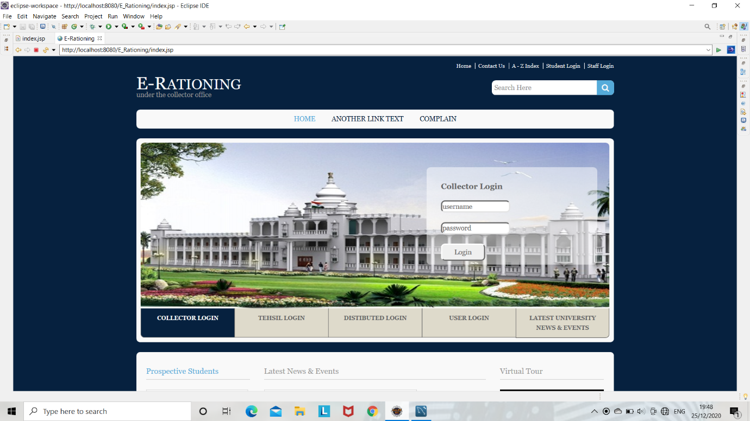

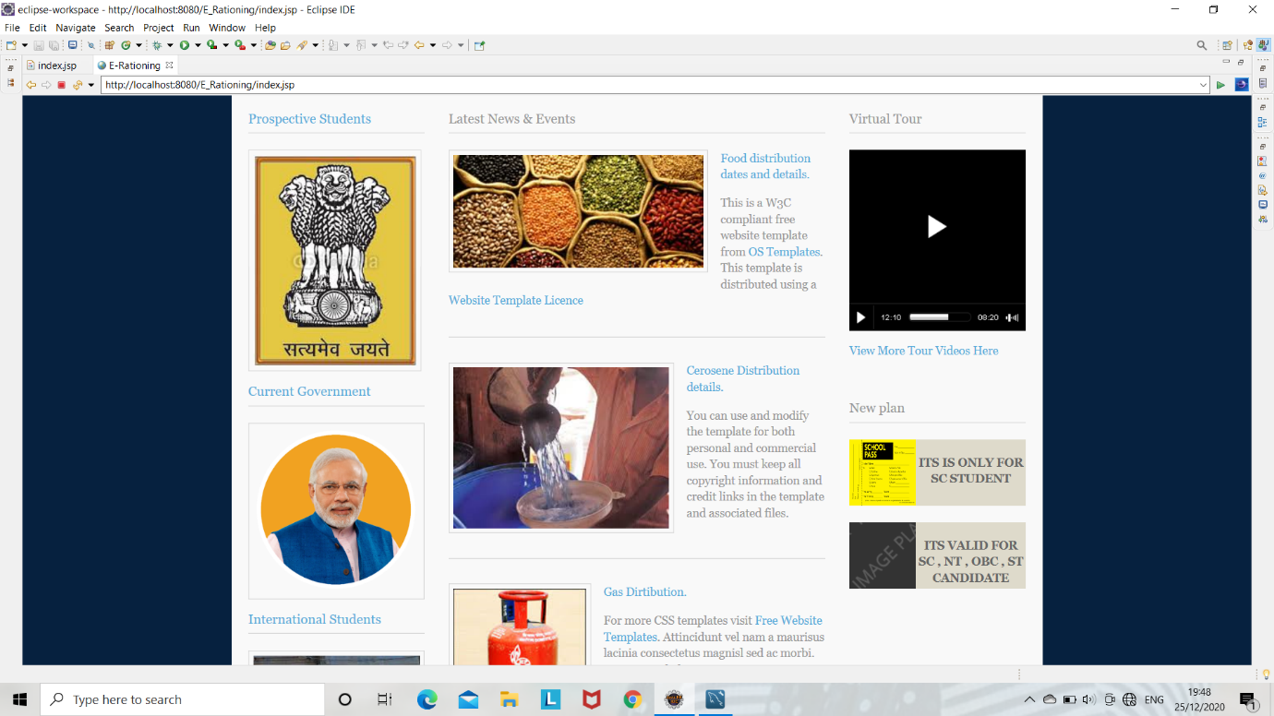

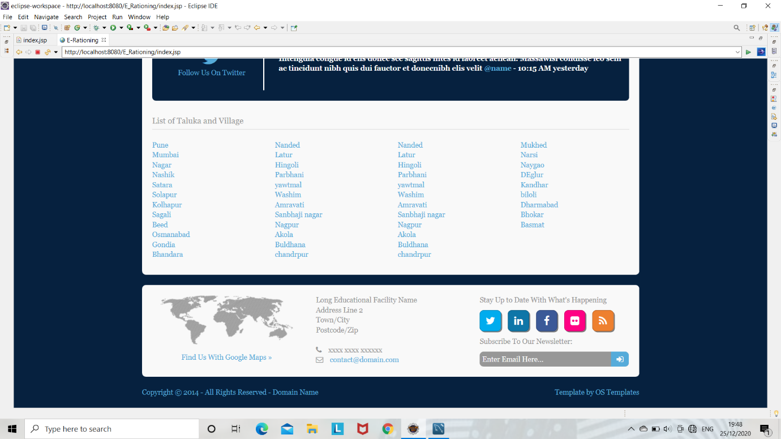

1. **Collector Login:**

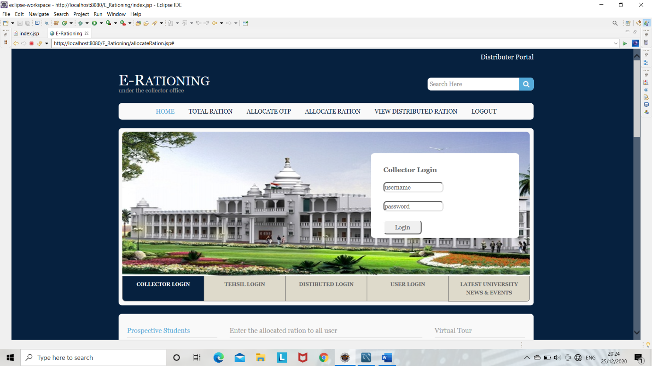

* **Tahsil Registration:**

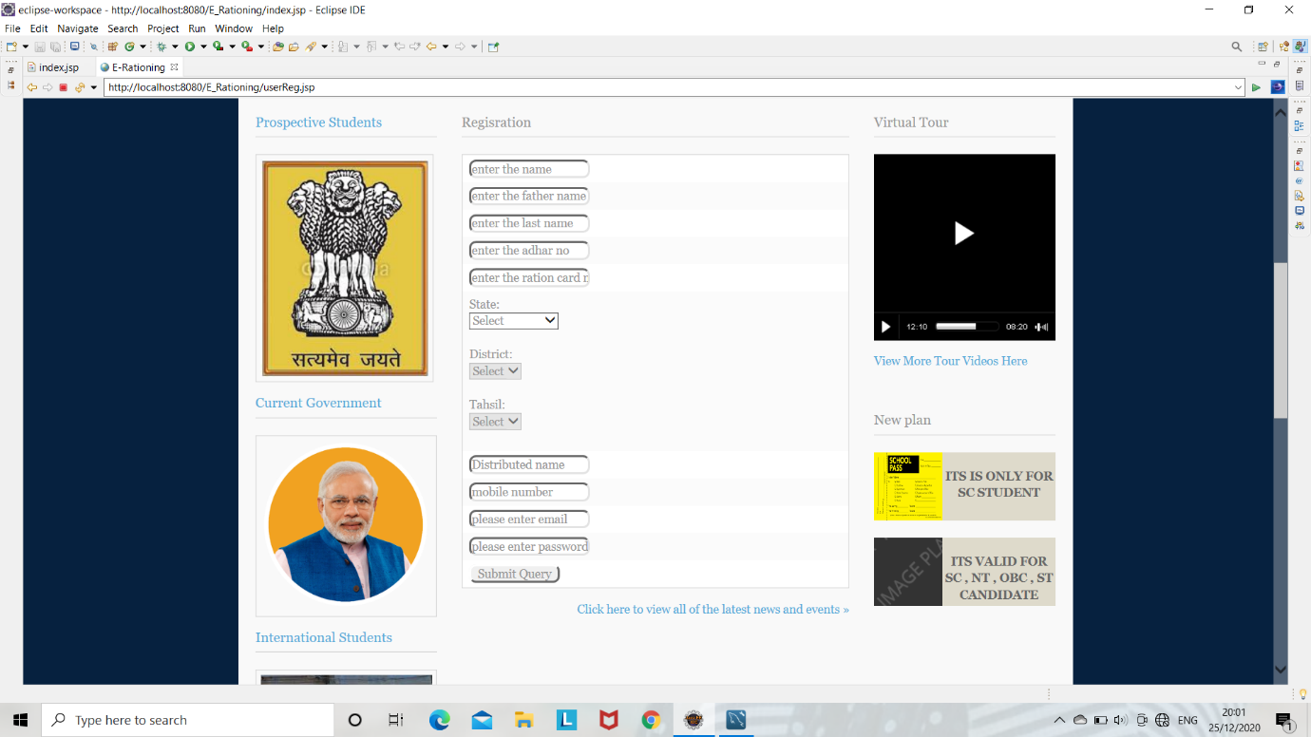

1. **Tahasil Login:**

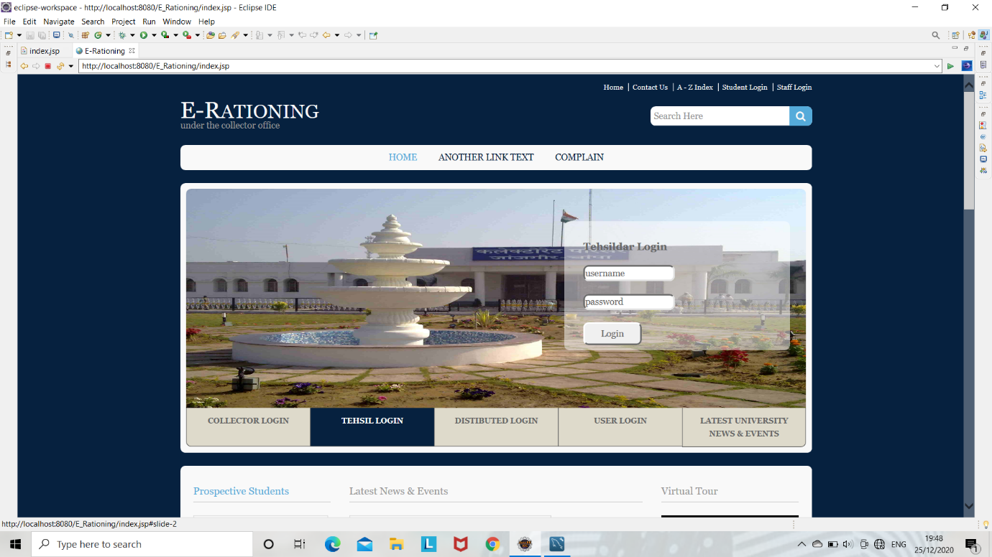

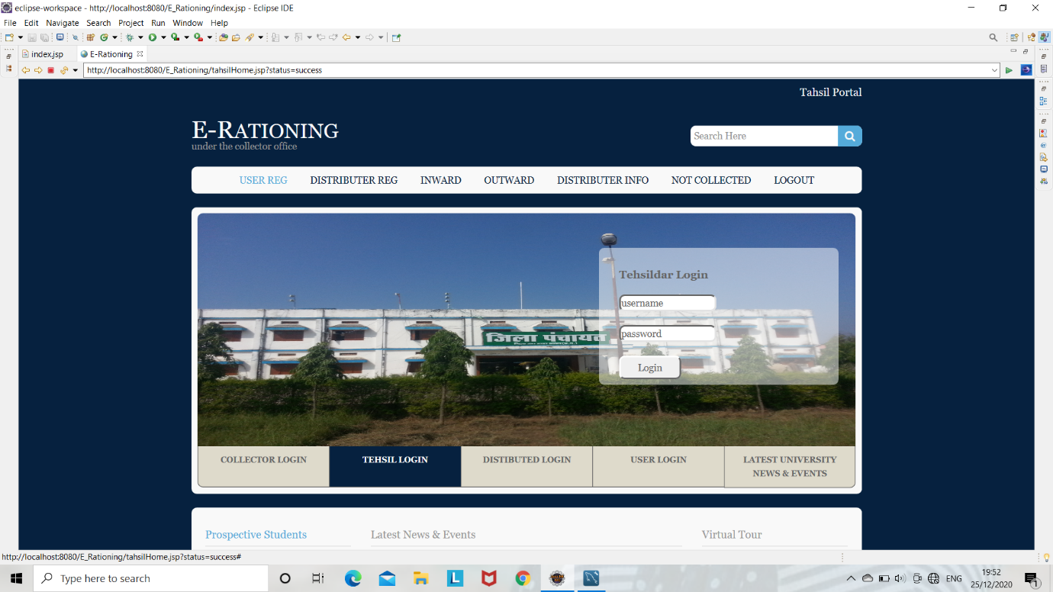

* **Distributer Registration:**

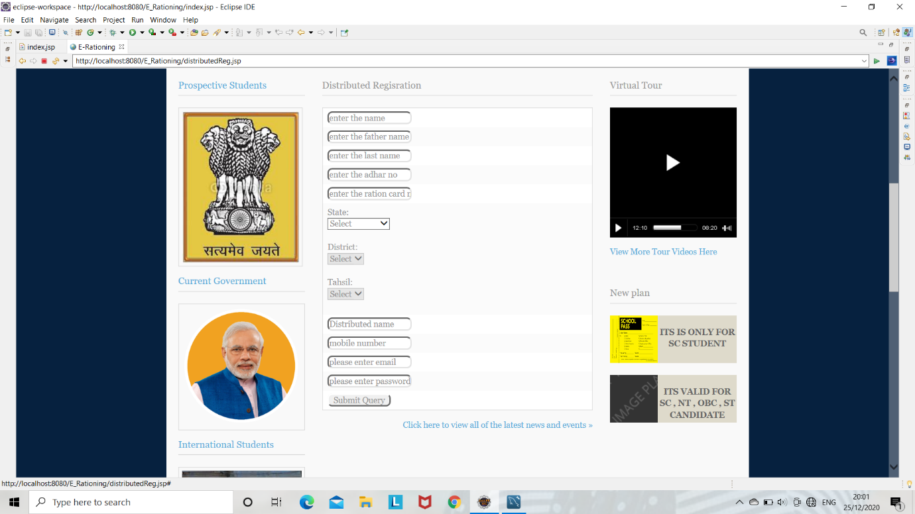

* **User Registration**



* **Allocate Ration To Distributor:**

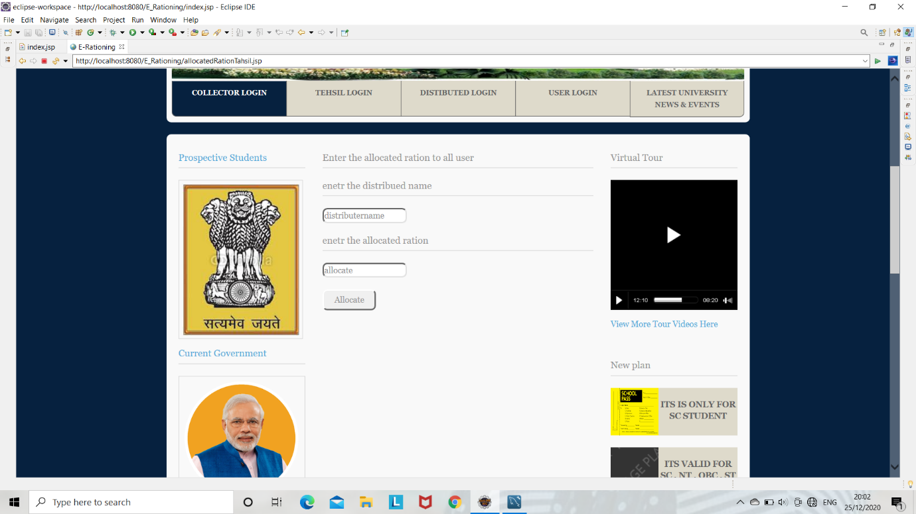

1. **Distributor Login:**

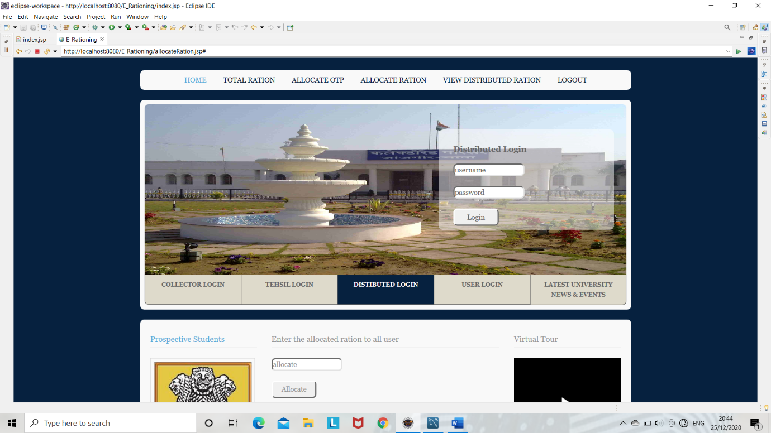

* **Allocate Ration and OTP To User:**

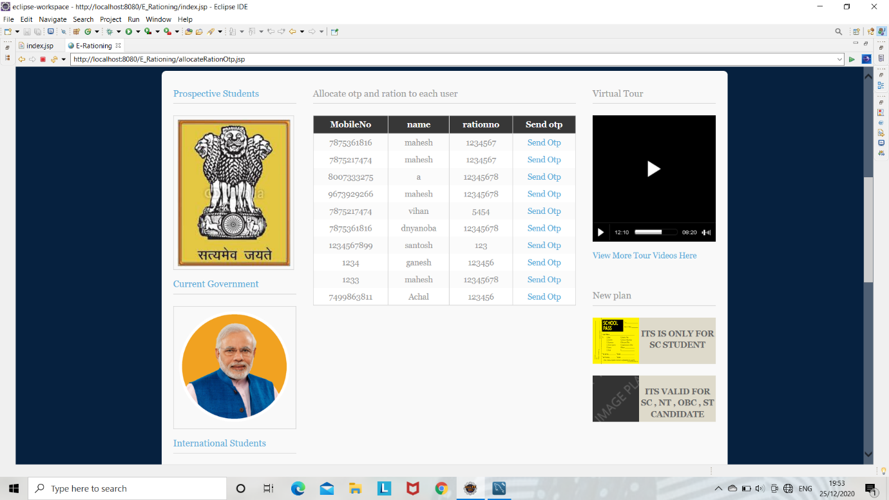

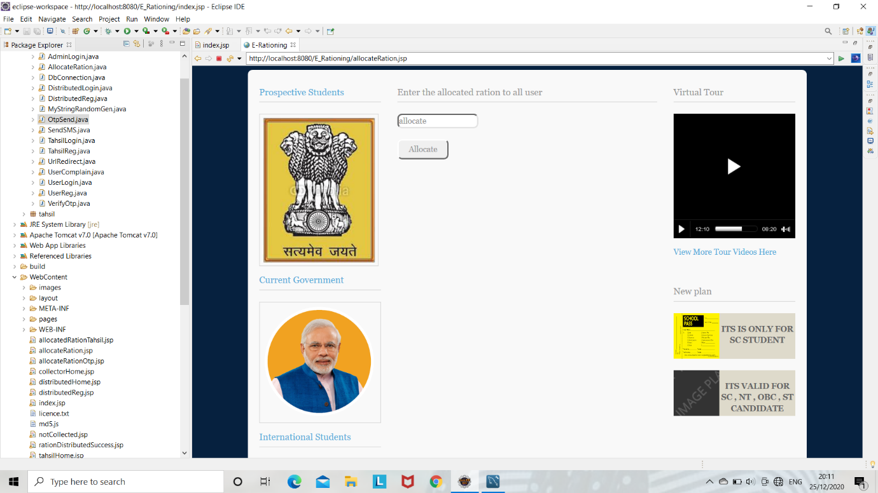

1. **User Login:**

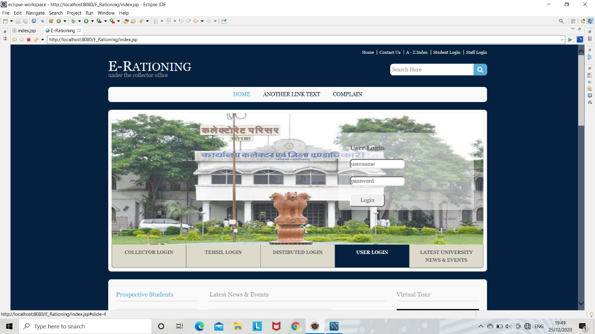

* **Allocated Ration:**

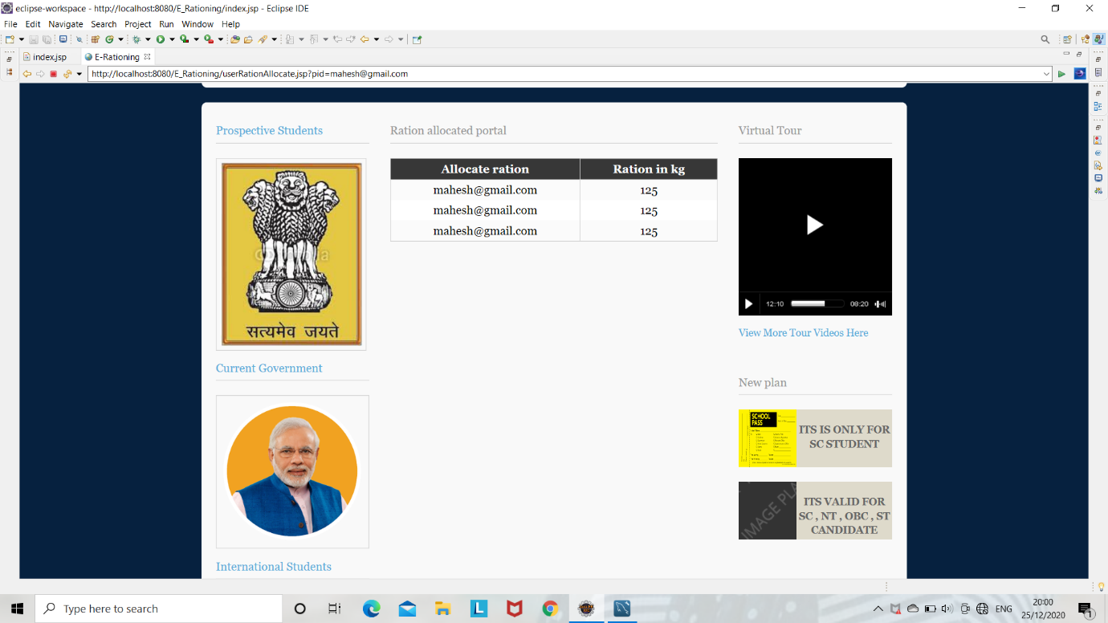

* **User Complain:**

